PROPOSAL FOR ENTERPRISE

LiveSafe Risk Mitigation

& Mobile Safety Communications Platform

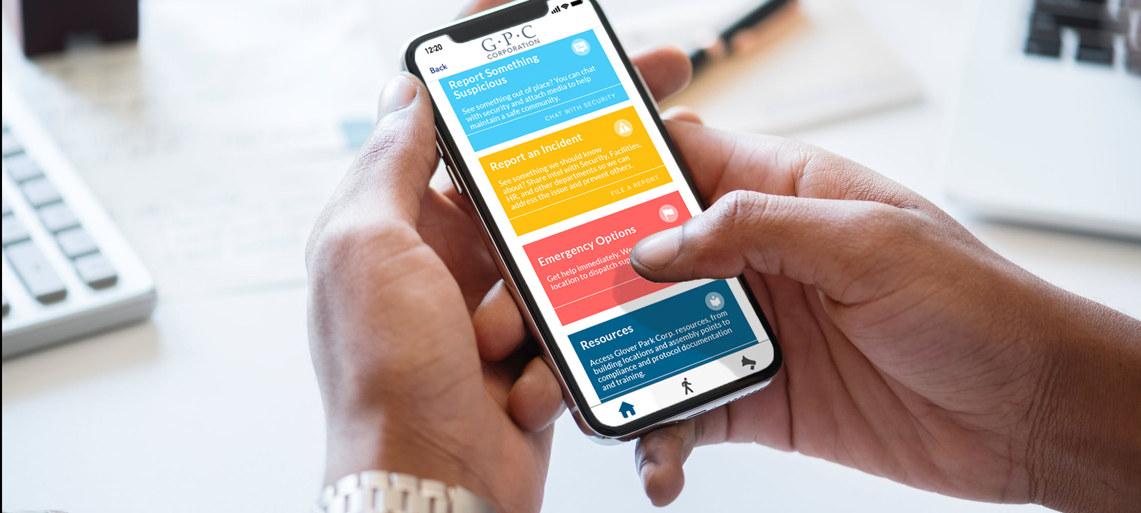

PREPARED FOR: [Customer]
ON: [Date]

VALID UNTIL: Month XX, 2018

Table of Contents

Executive Summary 3
Solution Overview 4
Company Overview 5
Implementation & Engagement 6
Platform & Technical Overview 7
- Redundancies 7
- Performance 7
- Supported Platforms 8
- Access & Data Security 8
- Integration & Partnership Options 9
Investment Summary & Options 10

Executive Summary

YOUR GOALS

Founded in [YEAR], [CUSTOMER] employs more than XXX staff members in over [NUMBER] [STATES/COUNTRIES]. Approximately [NUMBER] of those employees operate out of [LOCATION] [OFFICE/HEADQUARTERS]. The following proposal outlines a [NUMBER] (DIGIT) year contract for the LiveSafe Platform to deliver a risk mitigation and safety communications solution. The LiveSafe Platform empowers employees to surface incident-preventing insights. It delivers an enterprise-class communications platform to target safety updates to employees. The LiveSafe platform also delivers tools to empower the personal safety of [NUMBER] employees at [LOCATION].

DESIRED OUTCOME

[CUSTOMER] would like to provide a risk mitigation and safety communications solution that:

- Systemically removes the barriers employees traditionally encounter when coming forward with security and risk insights by taking away the complexity of navigating whether it’s something that should be reported, and whom they should tell. It also leverages the power of anonymity, allowing employees to share what they know without having to get involved.
- Delivers to employees access to safety and emergency communications capabilities that connects them to the teams protecting them — in everyday situations, and in higher risk ones.
- Gives employees the ability to quickly initiate a connection to local emergency services — regardless of where they are in the world — and to share their precise location in the event of an emergency.
- Empowers personal safety for all employees with peer-to-peer and self-service tools that deliver daily value. Employees get fingertip access to the safety resources the business has already created, even when there is no network connectivity. Employees also get access to LiveSafe’s SafeWalk feature, which allows them to invite friends to virtually accompany them to their destination.
- Delivers to the business an easy-to-access Command and Communications Dashboard which requires no incremental software or hardware investment to deploy. This provides real-time visibility into the employee sourced safety and security insights being surfaced, and is the gateway to the robust set of employee communications tools.
- Provides reporting and analytic capabilities to inform ongoing tuning of the deployment, and deliver a full audit trail on tip submissions and how they were managed.
- Is supported by LiveSafe’s Global Implementation Services Team, a dedicated group of experienced implementation experts, employing engagement best practices.

Solution Overview

This proposal outlines LiveSafe’s solution for empowering human sensors to contain risk and drive prevention. Risk is everywhere, and it’s costing businesses hundreds of billions of dollars annually. Across a broad range of risk categories, including sexual harassment, workplace related injuries and violence, cyber, malfeasance and more, the LiveSafe Platform has the ability to help businesses understand, measure, escalate, and respond to incidents. The LiveSafe Platform helps mitigate the potential damage these incident types can create for shareholders, to brand reputation, and most importantly in human terms. In addition to incident reporting functionality, The LiveSafe Platform also delivers robust safety communications capabilities as well as self-service and peer-to-peer personal safety tools which provide daily utility to both the business and to employees.

LiveSafe’s solution creates the conditions to bring the eyes and ears of key [CUSTOMER] employees into the risk mitigation stance for the business. The LiveSafe Platform is supported by flexible infrastructure that integrates seamlessly with the security and risk mitigation investments that have already been made. LiveSafe’s Global Implementation Services Team is standing by and ready to deliver a [CUSTOMER]-specific implementation that is dialed to the specific requirements of the business.

$52B  SPENT ON WORKPLACE-  RELATED INJURIES | $120B+  SPENT ON  WORKPLACE VIOLENCE | $10B+  SPENT ON  SEXUAL HARASSMENT
Reported by OSHA, it is estimated that U.S. companies spend over $1 billion per week for direct workers' compensation costs alone ¹. | Every year, almost two million U.S. workers report being a victim of workplace violence (and many more incidents go unreported). According to the National Institute for Occupational Safety and Health (NIOSH), workplace violence costs employers more than $120 billion a year ¹. | The Merit Systems Protection Board estimated that over two years... job turnover ($24.7M), sick leave ($14.9M), and decreased individual ($93.7M) and workgroup ($193.8) productivity had cost the government a total of $327.1M ¹ .

Company Overview

BORN TO TRIUMPH OVER TRAGEDY.

RAISED TO DELIVER RETURN ON PREVENTION.

Born from a spirit of triumph over tragedy, LiveSafe invents solutions that empowers employees to surface insights to protect the integrity of the work and campus communities they are invested in. LiveSafe empowers [CUSTOMER] with communications infrastructure to bi-directionally communicate with employees. LiveSafe empowers [CUSTOMER] employees tools to take charge of their personal safety.

LiveSafe has the direct involvement of a world-class Executive Advisory Board that includes some of the world’s leading risk and safety management experts, including former Governor Tom Ridge, the first Secretary of the U.S. Dept. of Homeland Security, Ray Kelly, leaders in the world’s biggest cities, and C-level executives. These experts receive regular updates, and their perspectives actively inform the strategy of the company, and the solutions that LiveSafe engineers.

LiveSafe is proud to have hundreds of clients including Fortune 500 companies in media, financial services, and technology, commercial real estate powerhouses, malls, hospitals, stadiums, arenas, professional sports teams/leagues, world-renown universities, and more. These clients inform the iterative evolution of the product portfolio.

CONTACT INFORMATION FOR LIVESAFE

[SALES REP]
[TITLE], LiveSafe, Inc.
m: [CELL]
e: [EMAIL]
1400 Key Blvd, Suite 100
Rosslyn, VA 22209

Implementation & Engagement

The LiveSafe Global Implementation Services Team (GIST) is a world-class division of experienced project managers. They optimize deployments for LiveSafe clients and are prepared to stand up implementations to support the entire spectrum of corporate functions: Physical Security, Environmental Health & Safety, Cyber, Human Resources, Compliance, and more.

Work begins with a consultative-driven kick-off rooted in understanding [CUSTOMER]’s business priorities. A [CUSTOMER]-specific implementation plan is architected, dialed to the specific needs and business structure of the company. The Global Implementation Services Team takes responsibility for ensuring the deployment mirrors and fully supports appropriate protocols that [CUSTOMER] has in place to address a wide range of business risk and issues.

The Global Implementation Services Team is available to consult with [CUSTOMER] employee communications and HR onboarding organizations to fuel success in the company-wide roll-out, and to bring new employees into the fold as they join. LiveSafe GIST is an active stakeholder throughout the lifecycle to support [CUSTOMER] in achieving a fully optimized deployment.

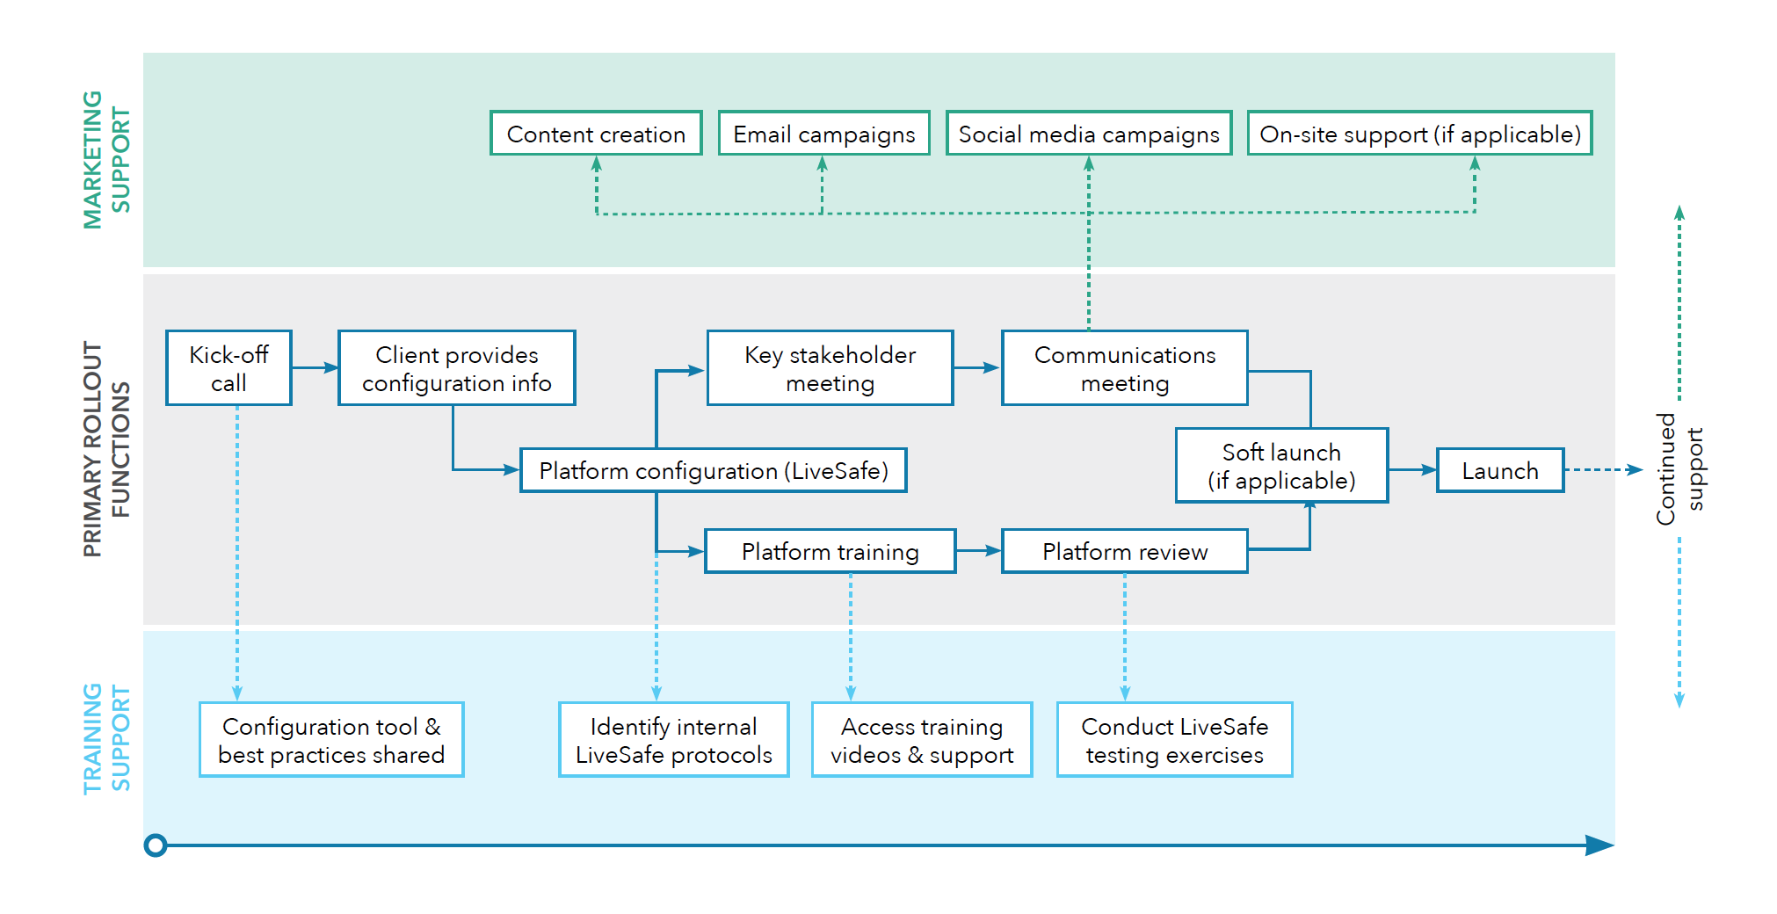

SAMPLE IMPLEMENTATION PLAN

Platform & Technical Overview

The LiveSafe Platform rests entirely on Amazon Web Services and also utilizes other third-party services (Open Market, Pubnub, etc.). This makes the platform highly available and highly scalable (machines autoscale based on demand).

REDUNDANCIES

Architectural Redundancy:
The LiveSafe Platform is housed in a virtual private cloud (VPC) within the AWS’s U.S. infrastructure. Web and database resources are replicated across multiple availability zones and multiple regions for redundancy.

High Capacity:
The LiveSafe Platform is architected to handle massive volumes of incoming and outgoing events, chats, and broadcasts in the event of a large-scale incident.

“Legacy models — tip lines, blue lights — can be costly, are grossly under-used, and just don’t work… I’ve never endorsed a product before or endorsed a movement, until LiveSafe.”

former NYC Police Commissioner, Ray Kelly

PERFORMANCE

Lightweight Install:
The LiveSafe Mobile App and implementations of the LiveSafe Mobile SDK use less than 20MB of device memory. Access the cloud-based dashboard via an Internet browser with no hardware or software install required.

Real-Time Location Service:
In standby mode, the LiveSafe Platform updates location at least every 50 meters based on speed and movement of the employee. In active mode, which is when an emergency option has been invoked or when the SafeWalk feature is in use, location is updated every 10-15 seconds. LiveSafe serves as a steward of employee privacy, and the employee’s location information is only passed through when the employee has initiated an emergency action, and even then the employee is alerted before location sharing begins.

Low Battery Consumption:
The value that the LiveSafe Solution can deliver goes up enormously when accurate location is maintained. The ability for employees to get help when an emergency option is invoked; the ability for friends to virtually accompany one another safely to their destinations; the ability to benefit from Geofenced Broadcast Messages — all of these scenarios require maintaining accurate location, and this is tied to battery consumption.
LiveSafe innovates to attain the right balance between the need to preserve battery life with the need to maintain accurate location for users, while safeguarding their privacy. That balance is achieved via architectural approaches as well as the discipline to embrace best practices and drive new innovation. This two-pronged approach ensures that the LiveSafe Mobile App does everything possible to “sip” battery power, while also unlocking the true value of the platform for both companies and for their constituencies.

 | SUPPORTED PLATFORMS  Internet Browsers (latest versions of):  - Google Chrome  - Mozilla Firefox  - Safari  - Microsoft’s Internet Explorer and Edge  Mobile OS:  - Apple phones/ tablets: iOS 8 +  - Android phones/tablets: Android 4.1 + | 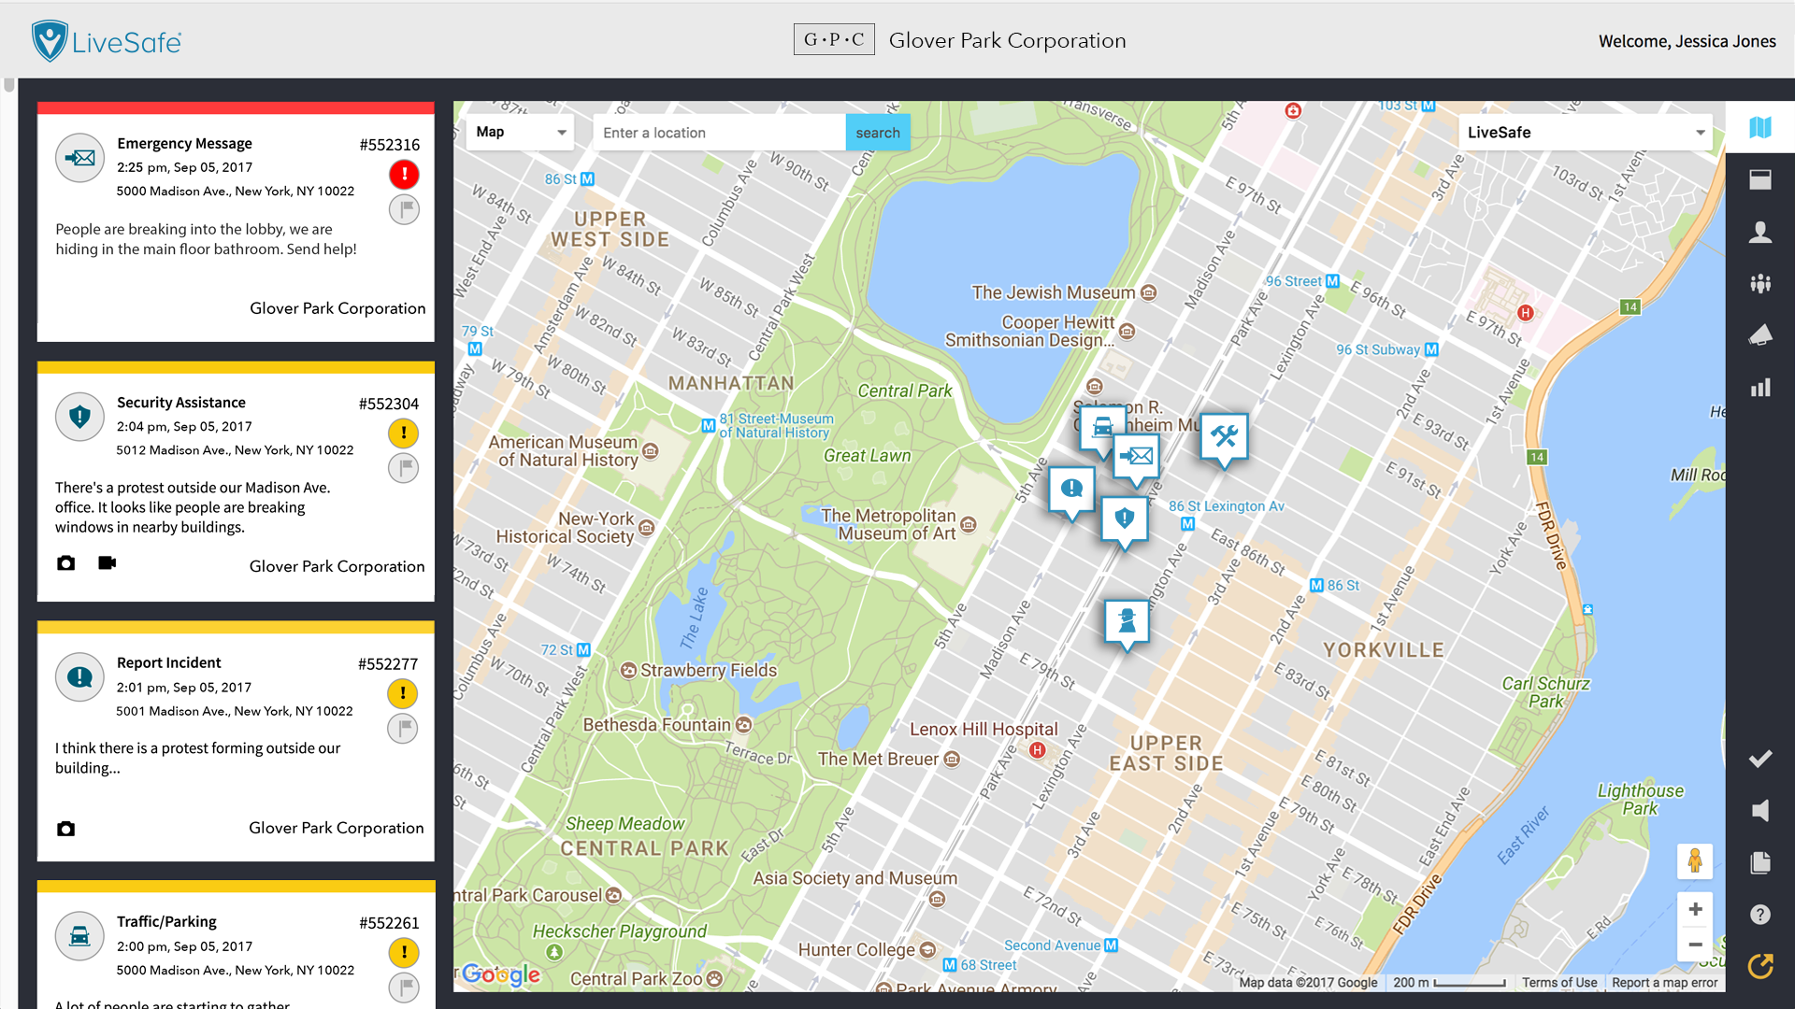
 |  | THE COMMAND AND COMMUNICATIONS DASHBOARD

ACCESS & DATA SECURITY

Enterprise Structures:
Flexible platform configuration for large, complex organizations — to better align with existing internal processes and flows of communication. Departments, offices, and regions can have customized instances of the LiveSafe Platform, all feeding into the global Security Operations Center.

Multi-Tenant Architecture:
Incident reporting, chat, and other data are logically separated and secured by limiting and auditing access to each organization.

Encryption:
All data is encrypted in transit using industry standard HTTPS/TLS. Core organization system data is encrypted at rest. To protect personal data, high-speed row level encryption of personal information — including first and last names, email addresses, and phone numbers — is employed. Data at rest is encrypted (AES-256) at the database level as well as at row level using a customer specific key that is managed by Amazon KMS.

Activity Audit:
All dashboard actions are automatically logged and time stamped to the admin that performed the action. Audits are stored separately from regular data and are not directly accessible by clients.

Administrator Privileges:
Command and Communications Dashboard users can be assigned or restricted access to specific administrator functions and hierarchical views.

SSO Login:
A user will be linked to their organization’s login page to allow for Single Sign-On to verify their access to the organization through a third-party federated identity tool (SAML 2.0 assertions).

Verified Email Domain:
The user must add a verified email from a specific organization owned domain (for example, user@companyx.com) if this option is selected.

Access PIN:
A 4-digit numeric pin, determined by the organization, must be entered to gain access if this option is selected.

User Management:
- Via SCIM integration and Automated User Management, share user data from internal systems to keep LiveSafe user data in sync.
- Via CSV uploader to bulk add large groups of people.

INTEGRATION &

PARTNERSHIP OPTIONS

LiveSafe Mobile SDK:
Embed essential functions of the LiveSafe Platform into existing iOS or Android app, seamlessly connecting people to help without having to download multiple apps.

Webhooks:
Have the LiveSafe Command and Communications Dashboard data feed into any platform of choice — seamlessly integrating into existing workflows and without requiring multiple app downloads.

THE LIVESAFE PLATFORM EMBEDDED

INTO THE ASIS 2017 SHOW APP

Investment Summary & Options

ENTERPRISE PACKAGE
Mobile App + Web-based Command and Communications Dashboard | ✓
Mass Notification Module | ✓
Tip Management Module | ✓
Real-Time Stats and Reporting | ✓
Mass Broadcast Geo-Fencing & Check-In | ✓
Global Implementation Services Team Consultant | ✓
24/7/365 Phone-Based Technical Support | ✓
Basic / Advanced Data Encryption | ✓
Custom Branding & Configuration | ✓
Internal Communications and Marketing Assistance | ✓
Dynamic Time and Geo-Location Based Rules | ✓
Parent / Child Dashboards | ✓
Single-Sign-On (SSO) and Identity Management Integration | ✓
Number of Dashboard Administrators | 3 / 10 / Unlimited

SET-UP & IMPLEMENTATION FEES (REQUIRED)
Virtual Implementation and Set-Up (up to 3 days) | $2,500
Onsite Implementation and Set-Up (up to 3 days) | $7,500
Custom Integrations and Additional Professional Services | $2,000 per day + travel

NUMBER (X) YEAR CONTRACT COMMITMENT
Annual Fee | $XX,XXX

Conservatively, the costs of workplace incidents in the US exceeds $300B annually. Workplace Violence costs employers $120B+ annually (Nackerman Insurance Services, https://goo.gl/XC76sb); Sexual Harassment costs $10B+, (ERC, https://goo.gl/bGjBvv); Workplace Injury costs $52B+ (OSHA, https://goo.gl/q7L2dS); Cyber costs $100B+ (Fortune, https://goo.gl/50sDAa); Malfeasance costs $100B+ (SMH, https://goo.gl/dv2n6M).
One of LiveSafe’s co-founders is Kristina Anderson, who was one of the most critically injured survivor of the 2007 Mass Shooting at Virginia Tech.
Why Uber Can Find You but 911 Can’t” Wall Street Journal, Jan. 7, 2018, https://goo.gl/pSHLt7. USC Campus Police and LAPD use LiveSafe Mobile App to locate female USC student within 12 minutes, and stop sexual battery in progress. LA Times, CBS|2 News, Nov. 23, 2015. https://goo.gl/prCTqc

